**Overview**

The **Zscaler Test – AnyConnect Profile** – Switcher utility was created to allow Mac laptops to disconnect from the VPNs while maintaining internet connectivity in support of Zscaler Pilot Phase. The utility has been made available to your Mac laptop for install via Self Service.

1. Visit **Self Service** and install **AnyConnect Switchable (On/Off) Profile.**

1. Verify you can disconnect From **AnyConnect** and access internet sites.

**Note:** Auth failures to O365 and other CFPB resources are expected at this point.

1. Logo

   Description automatically generatedVisit **Self Service** and install **Zscaler Test** Install.

**Note:** The **Zscaler** client should open automatically. You may see both, either, or neither of the screens below.

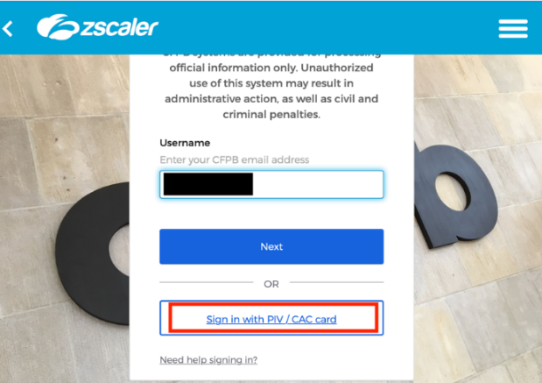

1. Graphical user interface, text, application

   Description automatically generated If prompted to log in, choose **certificate** if you have a PIV card. Otherwise, use username and password.
2. To Log in with your PIV certificate, enter the PIN number as shown here.

1. When authenticated, the Zscaler app **Menu bar** will show options.

**Private Access** **Internet Security**

If you have any additional questions or comment on the test script, please, please submit a RITM and assign the task to the **Zscaler Pilot** Assignment group.